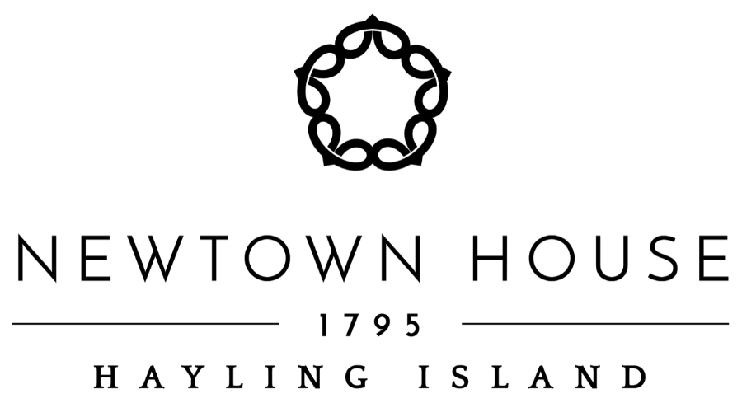

**Christmas Party Set Menu 2024.**

**2 Courses £32.95**

**3 Courses £37.95**

**Creamy Mushroom & Thyme Soup**   
Served with a Crusty Roll and Butter

**Honey Glazed Goat Cheese**

Topped with Roasted Walnuts and served with Salad Garnish and Balsamic Reduction

**Homemade Chicken and Ham Hock Terrine**Served with Salad Garnish, Gherkins and Toasted Ciabatta

**Chef’s Salmon Terrine**On a Cucumber Bed with a Beetroot & Horseradish Cream and Toasted Ciabatta

**---------**

**Traditional Slow Roasted Norfolk Turkey**With Apricot & Pistachio Stuffing, Pigs in Blankets, Roast Potatoes  
  
**Roast Topside of Beef**  
With Yorkshire Pudding and Red Wine Gravy

**Fillet of Salmon**   
Served with Creamy Sweet Chilli Mango-Salsa and Roast Potatoes

**Savory Vegetarian Handmade Pies (available as a Vegan option)**

Filled with Caramelised Onion, Spinach, Wild Mushrooms, Butternut Squash and Cheddar

***All served with traditional seasonal vegetables***

**-----------**

**Traditional Christmas Pudding (available as a Vegan option)  
Served with Brandy sauce**

**Warm Chocolate Brownie**Served with Vanilla Ice-cream

**Duet of Chef’s Parfait Pistachio & Raspberry**

Served with Forest Fruits and Mango Coulis

**Selection of Cheese** **and Biscuits**  
Served with Celery and Grapes